**USDA-NRCS**

GEOSPATIAL TECHNOLOGY APPLICATIONS

**CERTIFIED WETLAND DETERMINATION GEOSPATIAL DATA MODEL AND MAPPING STANDARD**

VERSION 3.0

NRCS USE ONLY

August 12, 2020

Table of Contents

1. Introduction 1

1.1 Background 1

1.2 Objectives 2

1.3 Scope 2

1.4 Applicability 2

2. Data Model 3

2.1 Local Data Model 3

2.1.1 CLU Feature Class 3

2.1.2 Tract Feature Class 6

2.1.3 Determination Extent Feature Class 7

2.1.4 Sampling Unit Feature Class 7

2.1.5 Representative Observation Point (ROP) Feature Class 12

2.1.6 Drainage Lines Feature Class 16

2.1.7 Potential Jurisdictional Waters Feature Class 18

2.1.8 Preliminary Technical Determination (PTD) Feature Class 19

2.1.9 Certified Wetland Determination (CWD) Feature Class 22

2.1.10 Compliance Records Tract Index Feature Class 27

2.1.11 State Administrative Feature Class 27

2.2 GeoPortal Data Model 27

2.2.1 Current Sampling Units 27

2.2.2 All Sampling Units (Pending) 28

2.2.3 Current Wetland Determinations 28

2.2.4 All Wetland Determinations 28

2.2.5 Current Certified Wetland Determinations 29

2.2.6 All Certified Wetland Determinations (Pending) 29

2.2.7 Determination Job Extents 29

2.2.8 Determination Job Points 30

2.2.9 Determination Points 30

2.3 Data Model Domains 30

2.3.1 YN Domain 31

2.3.2 Yes-No Domain 31

2.3.3 ROP Status Domain 31

2.3.4 Data Form Domain 31

2.3.5 Line Type Domain 31

2.3.6 Pre-Post Domain 31

2.3.7 Method Domain 31

2.3.8 CWD Status Domain 31

2.3.9 Request Type Domain 32

2.3.10 Evaluation Status Domain 32

2.3.11 Wetland Labels Domain 32

2.4 Source Datasets 33

2.4.1 FSA CLU (from FSA Web Service) 33

2.4.2 NRCS Soil Survey (Soil Data Access) 33

2.4.3 USGS NHD 33

2.4.4 US FWS National Wetland Inventory (NWI) 33

2.4.5 USGS Topographic Quadrangle Maps 33

2.4.6 Best Available NAIP 33

2.4.7 NRCS Elevation Services 33

2.4.8 NRCS Wetland Determination Climate Data (WETS) 33

2.4.9 Local Digital Datasets 33

2.5 Coordinate Systems 34

2.5.1 GeoPortal Layers 34

2.5.2 State/Local APRX Template Maps 34

2.5.3 Determination Tool Project Datasets 34

2.5.4 Local Reference Datasets 34

2.6 Accuracy 34

2.6.1 Horizontal Accuracy 34

2.6.2 Accuracy Assessment 35

2.7 Topology Rules and Logical Consistency (Pending) 35

2.8 Metadata (Pending) 35

3. References 35

4. Participants 36

1. Introduction

This version is to provide a geospatial data model and mapping standard for supporting a wetland determinations mapping tool used to create wetland determination products and to upload data into a Certified Wetland Determinations hosted feature service for each state, prior to the implementation of these types of workflows in Conservation Desktop. This data model and the referenced tool are not directly linked to the HELC/WC Tracker in Conservation Desktop.

* 1. Background

Eligibility for USDA Program benefits related to the 1985 Food Security Act (Act), as amended, Wetland Conservation (WC) provisions are determined by a cooperative effort between Farm Service Agency (FSA) and the Natural Resources Conservation Service (NRCS). NRCS follows guidance from the National Food Security Act Manual Fifth Edition (NFSAM), which states the following for delineating wetlands:

“The Food Security Act of 1985, as amended, requires NRCS to delineate, determine, and certify wetlands located on land on a farm or ranch subject to wetland conservation (WC) provisions in order to establish a producer’s eligibility for certain USDA program benefits (16 U.S.C. Section 3822, 7 CFR Section 12.30).”

In addition, NFSAM specifies the manner in which NRCS will prepare the certified wetland determination and delineation, as follows:

“NRCS will delineate all wetlands subject to the WC provisions by outlining the boundaries of the wetland on aerial photography, digital imagery, or other graphic representation. If possible, NRCS will use the Global Positioning System (GPS) to digitally map the wetland boundary in the field and to import that data onto digital orthophotoquadrangle maps (DOQ) or other Geographic Information System (GIS) digital photographic imagery. Refer to Part 514, Subparts B through E, to determine the appropriate labels to apply to the delineated wetland types.”

“The complete boundaries and size of all fields that were delineated and identified must be shown on the map, including areas identified as non-wetland (NW). The label and acreage information from the map will be used to prepare the NRCS-CPA-026. A copy of the NRCS-CPA-026, along with the delineation map, will be provided to the USDA program participant and FSA and retained in the participant’s NRCS case file.”

FSA began converting Common Land Unit (CLU) boundaries to digital data in the late 1990’s. The CLU boundaries were captured from existing FSA aerial imagery upon which the CLU tract and field boundaries had been manually delineated. The physical copy of the imagery at the time also contained the official USDA wetland determinations mandated by the Act. During the CLU development process, FSA chose not to capture the wetland boundary determinations, but rather to identify the occurrence of a wetland with a blue dot symbol within a farm field boundary. The use of the blue dots was an interim step to NRCS developing and maintaining a GIS dataset reflecting wetland boundary delineations and designations (NRCS FSA, 2006).

* 1. Objectives

The objective of this data model and standard is to support the implementation of an enterprise-lite version of a wetland determination tool to meet the requirements of the NFSAM for accurate delineation and identification of wetlands for compliance with the WC provisions of the Act. The elements of this standard have been developed to facilitate and ensure certified wetland determinations are completed, retrievable, and recorded consistently.

* 1. Scope

This data model and standard will apply to the Certified Wetland Determination dataset, and related datasets, to represent the location and identification of areas that have been mapped and considered to have a certified wetland determination defined by the Act in the United States and Territories subject to the Act.

* 1. Applicability

This data model and mapping standard is for use by NRCS to develop an interim wetland determination tool and related geospatial datasets that will create products for issuing, and retaining records of, a wetland determination. This data model and mapping standard will eventually be replaced by tools, workflows, and datasets integrated into the Conservation Desktop application.

1. Data Model

The geospatial data model is built around two components, a local component and an online component using the NRCS GeoPortal. The local component is built around feature classes and tabular data. The GeoPortal component is built around hosted feature layers, web maps, and operations dashboards. The model is designed to capture the complex requirements for the determination data and workflow. Implementation of this data model and mapping standard will enhance effective customer service, response times, and conservation delivery implementation.

* 1. Local Data Model

Local feature classes are maintained as templates in a source geodatabase in the tool installation folder. They are then called and processed on a per project basis by the wetland determination tool and its workflow. Project files are managed on a per site basis and feature class creation, updates, and topology are maintained by validation rules and functions built into the wetland determination tool workflow. These data are used to define the project site and request extent, the sampling units, and the determination delineations for each project. Local Data from each project is passed into the GeoPortal data model and its hosted feature layers.

* + 1. CLU Feature Class

The CLU Feature Class is a polygon feature class consisting of a copy of all fields from a single tract of the FSA CLU layer. Field data is used to provide administrative data to the current project and field extents are used to promote alignment of data within the current project.

* + - 1. Workflow Components and Relationships

The CLU Feature Class is created by downloading all fields of a specified CLU Tract from the FSA CLU web service and storing them in a local file geodatabase for the current project. This feature class is then used to select CLU fields which contain areas to be determined, to create a tract boundary layer, and as part of creating the current project’s Certified Wetland Determination Feature Class. This feature class is also used for cartographic purposes during the workflow. This feature class is added to the current project’s map as a layer.

* + - 1. Attributes

Attributes are inherited from the downloaded FSA CLU layer. FSA CLU attributes not listed here are dropped from this feature class upon its creation.

1. *Name*: GlobalID (Required)

*Alias*: GlobalID

*Data Type*: Global ID

*Value Description*: System Generated. Unique ID per feature.

*Default Value*: System generated

1. *Name*: admin_state (Required)

*Alias*: admin_state

*Data Type*: String/Text

*Length*: 2

*Value Description*: 2-character FIPS code representing the administrative state or territory of each CLU field

*Default Value*: Inherited from import

1. *Name*: admin_state_name (Required)

*Alias*: Admin State Name

*Data Type*: String/Text

*Length*: 64

*Value Description*: Administrative state name

*Default Value*: Computed from lookup table

1. *Name*: admin_county (Required)

*Alias*: admin_county

*Data Type*: String/Text

*Length*: 3

*Value Description*: 3-character FIPS code representing the administrative county or parish of each CLU field

*Default Value*: Inherited from import

1. *Name*: admin_county_name (Required)

*Alias*: Admin County Name

*Data Type*: String/Text

*Length*: 64

*Value Description*: Administrative county name

*Default Value*: Computed from lookup table

1. *Name*: state_code (Required)

*Alias*: state_code

*Data Type*: String/Text

*Length*: 2

*Value Description*: 2-character FIPS code representing the geographic state or territory of each CLU field

*Default Value*: Inherited from import

1. *Name*: state_name (Required)

*Alias*: State Name

*Data Type*: String/Text

*Length*: 64

*Value Description*: Geographic state name

*Default Value*: Computed from lookup table

1. *Name*: county_code (Required)

*Alias*: County Code

*Data Type*: String/Text

*Length*: 3

*Value Description*: 3-character FIPS code representing the geographic county or parish of each CLU field

*Default Value*: Inherited from import

1. *Name*: county_name (Required)

*Alias*: County Name

*Data Type*: String/Text

*Length*: 64

*Value Description*: Geographic county name

*Default Value*: Computed from lookup table

1. *Name*: farm_number (Required)

*Alias*: Farm Number

*Data Type*: String/Text

*Length*: 7

*Value Description*: A 1- to 7-digit farm number for each CLU field

*Default Value*: Inherited from import

1. *Name*: tract_number (Required)

*Alias*: Tract Number

*Data Type*: String/Text

*Length*: 7

*Value Description*: A 1- to 7-digit tract number for each CLU field

*Default Value*: Inherited from import

1. *Name*: clu_number (Required)

*Alias*: CLU Number

*Data Type*: String/Text

*Length*: 7

*Value Description*: A 1- to 7-digit field number for each CLU field

*Default Value*: Inherited from import

1. *Name*: clu_calculated_acreage (Required)

*Alias*: CLU Calculated Acreage

*Data Type*: Double

*Value Description*: The acres for each CLU field as calculated by FSA. FSA MIDAS calculates acres by multiplying square meters in NAD83 UTM coordinate systems for the field location by 0.0002471. This conversion factor causes a slight discrepancy from actual acres (should use 0.000247105).

*Default Value*: Inherited from import

1. *Name*: highly_erodible_land_type_code (Optional)

*Alias*: Highly Erodible Land Type Code

*Data Type*: String/Text

*Length*: 4

*Value Description*: The HEL determination attribute for the field stored by FSA: UHEL, NHEL, or HEL. This attribute is only used as reference information in the wetland determination workflow. It is otherwise reserved for future use.

*Default Value*: Inherited from import

1. *Name*: creation_date (Optional)

*Alias*: Creation Date

*Data Type*: Date

*Value Description*: FSA tracking attribute from its database for the date that the field record was created.

*Default Value*: Inherited from import

1. *Name*: last_change_date (Optional)

*Alias*: Last Change Date

*Data Type*: Date

*Value Description*: FSA tracking attribute from its database for the date that the field record was last modified.

*Default Value*: Inherited from import

* + 1. Tract Feature Class

The Tract Feature Class is a polygon feature class that consists of the outer extent of all CLU fields for the specified tract. It is used to control the maximum editing extent for the current determination project.

* + - 1. Workflow Components and Relationships

The Tract Feature Class is created by dissolving together the CLU Feature Class by Admin State, Admin State Name, Admin County, Admin County Name, State Code, State Name, County Code, County Name, Farm Number, and Tract Number and gets stored in the local project’s file geodatabase. It is used as a starting point to buffer an extent for use in generating supplemental reference datasets to display with the current determination project. The buffer is 500 feet. This feature class is not added to the current project’s map as a layer.

* + - 1. Attributes

Attributes are inherited from the downloaded FSA CLU layer through the dissolve process. FSA CLU attributes at the tract level are retained, and attributes at the CLU Number (or field) level are dropped. This results in omitting CLU Number, CLU Calculated Acreage, Highly Erodible Land Type Code, Creation Date, and Last Change Date from this layer.

* + 1. Determination Extent Feature Class

The Determination Extent Feature Class is a polygon feature class that is used to define the maximum extent of the requested area for determination for the current site or project. It can be multipart.

* + - 1. Workflow Components and Relationships

The Determination Extent Feature Class is created automatically as a copy of the CLU Feature Class and is intended for users to edit into subfields, if necessary. Whether or not users create subfields to refine the extent, the Determination Extent Feature Class is then updated during the step to run the Create Sampling Unit Layers tool based on user-selected fields and subfields, or clipped based on a user-defined AOI that has no relationship to field boundaries. After this step, the extent is used in the workflow to enforce the maximum determination extent for the site.

* + - 1. Attributes

Attributes are mostly the same as the tract level attributes of the CLU Feature Class. Additional attributes are listed here:

1. *Name*: eval_status

*Alias*: Evaluation Status

*Data Type*: String/Text

*Length*: 24

*Domain*: Evaluation Status

*Value Description*: The workflow type or status of the current polygon feature derived from the determination extent feature class.

*Default Value*: New Request (or others depending on workflow)

* + 1. Sampling Unit Feature Class

The Sampling Unit Feature Class is a polygon feature class that is used to define the extent and its sampling units.

* + - 1. Workflow Components and Relationships

The Sampling Unit Feature Class is created by copying user-selected fields from the CLU feature class and transferring them to a template Sampling Unit Feature Class and limiting the initial maximum extent by the Determination Extent Feature Class. While editing, users have the option to remove field lines and extend sampling unit extents outside of the maximum determination extent. Edits are made on the Sampling Unit Feature Class to delineate sampling units and populate their attributes. This feature class is also integrated with any previous determination sampling unit extents within the determination extent to assist with data alignment or the revision process. This feature class has internal topology requirements to not overlap with itself for the current project. This feature class is added to the current project’s map as a layer.

* + - 1. Attributes

Some attributes are inherited from the CLU and others are populated automatically or through user edits.

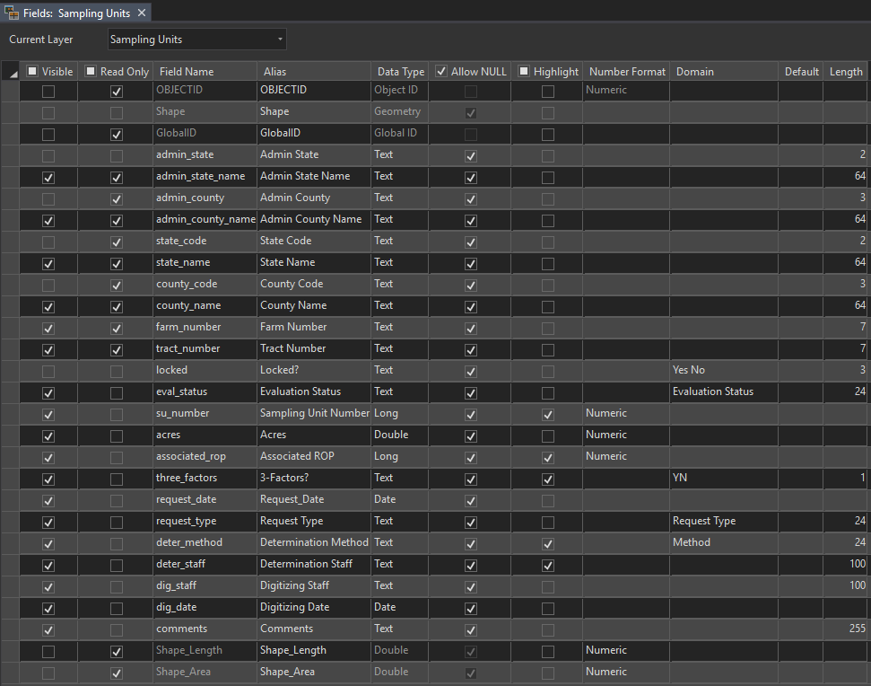

1. *Name*: GlobalID (Required)

*Alias*: GlobalID

*Data Type*: Global ID

*Value Description*: System Generated. Unique ID per feature.

*Default Value*: System generated

1. *Name*: admin_state (Required)

*Alias*: Admin State

*Data Type*: String/Text

*Length*: 2

*Value Description*: 2-character FIPS code representing the administrative state or territory of each CLU field

*Default Value*: Inherited from CLU Feature Class

1. *Name*: admin_state_name (Required)

*Alias*: Admin State Name

*Data Type*: String/Text

*Length*: 64

*Value Description*: Administrative state name

*Default Value*: Inherited from CLU Feature Class

1. *Name*: admin_county (Required)

*Alias*: Admin County

*Data Type*: String/Text

*Length*: 3

*Value Description*: 3-character FIPS code representing the administrative county or parish of each CLU field

*Default Value*: Inherited from CLU Feature Class

1. *Name*: admin_county_name (Required)

*Alias*: Admin County Name

*Data Type*: String/Text

*Length*: 64

*Value Description*: Administrative county name

*Default Value*: Inherited from CLU Feature Class

1. *Name*: state_code (Required)

*Alias*: State Code

*Data Type*: String/Text

*Length*: 2

*Value Description*: 2-character FIPS code representing the geographic state or territory of each CLU field

*Default Value*: Inherited from CLU Feature Class

1. *Name*: state_name (Required)

*Alias*: State Name

*Data Type*: String/Text

*Length*: 64

*Value Description*: Geographic state name

*Default Value*: Inherited from CLU Feature Class

1. *Name*: county_code (Required)

*Alias*: County Code

*Data Type*: String/Text

*Length*: 3

*Value Description*: 3-character FIPS code representing the geographic county or parish of each CLU field

*Default Value*: Inherited from CLU Feature Class

1. *Name*: county_name (Required)

*Alias*: County Name

*Data Type*: String/Text

*Length*: 64

*Value Description*: Geographic county name

*Default Value*: Inherited from CLU Feature Class

1. *Name*: farm_number (Required)

*Alias*: Farm Number

*Data Type*: String/Text

*Length*: 7

*Value Description*: A 1- to 7-digit farm number for each CLU field

*Default Value*: Inherited from CLU Feature Class

1. *Name*: tract_number (Required)

*Alias*: Tract Number

*Data Type*: String/Text

*Length*: 7

*Value Description*: A 1- to 7-digit tract number for each CLU field

*Default Value*: Inherited from CLU Feature Class

1. *Name*: locked (Required)

*Alias*: Locked

*Data Type*: String/Text

*Length*: 3

*Domain*: Yes-No

*Value Description*: A yes or no indicator intended to control whether the feature can be edited. Placeholder in this version/implementation.

*Default Value*: No

1. *Name*: eval_status

*Alias*: Evaluation Status

*Data Type*: String/Text

*Length*: 24

*Domain*: Evaluation Status

*Value Description*: The workflow type or status of the current polygon feature derived from the determination extent feature class.

*Default Value*: New Request (or others depending on workflow)

1. *Name*: su_number (Required)

*Alias*: Sampling Unit Number

*Data Type*: Long Integer

*Value Description*: A number assigned by the user to uniquely identify each sampling unit.

*Default Value*: Null

1. *Name*: acres (Required)

*Alias*: Acres

*Data Type*: Double

*Value Description*: Acres calculated by ArcGIS.

*Attribute Rule*: Calculate upon feature insert or update.

*Default Value*: Calculated by GIS on layer creation/updates.

1. *Name*: associated_rop (Required)

*Alias*: Associated ROP

*Data Type*: Long Integer

*Value Description*: The ROP Number of an associated ROP.

*Default Value*: Null

1. *Name*: three_factors (Required)

*Alias*: 3-Factors

*Data Type*: String/Text

*Length*: 3

*Domain*: YN

*Value Description*: Y or N. Set to Y or N based on findings while delineating for whether the three factors for wetlands are confirmed.

*Default Value*: Null

1. *Name*: request_date (Required)

*Alias*: Request Date

*Data Type*: Date

*Value Description*: The date of the request that prompted the determination.

*Default Value*: Assigned from required user parameters

1. *Name*: request_type (Required)

*Alias*: Request Type

*Data Type*: String/Text

*Length*: 12

*Value Description*: The type of request that prompted the determination.

*Default Value*: Assigned from required user parameters

1. *Name*: deter_method (Required)

*Alias*: Determination Method

*Data Type*: String/Text

*Length*: 24

*Value Description*: Selected by the user after creating the feature.

*Domain*: Method

*Default*: Null

1. *Name*: deter_staff (Required)

*Alias*: Determination Staff

*Data Type*: String/Text

*Length*: 100

*Value Description*: The name of the person who is doing or did the determination delineations.

*Default Value*: Current user

1. *Name*: dig_staff (Required)

*Alias*: Digitizing Staff

*Data Type*: String/Text

*Length*: 50

*Value Description*: The name of the person who is digitizing the determination.

*Default Value*: Current user

1. *Name*: dig_date (Required)

*Alias*: Digitizing Date

*Data Type*: Date

*Value Description*: The date of the last edit to the feature.

*Default Value*: Current date or date of last edit/validate

1. *Name*: comments (Optional)

*Alias*: Comments

*Date Type*: String/Text

*Length*: 255

*Value Description*: Used to record any other comments, as needed.

*Default Value*: Null

* + 1. Representative Observation Point (ROP) Feature Class

The ROP Feature Class is a point feature class that is used to mark locations of representative observations for a wetland determination.

* + - 1. Workflow Components and Relationships

The ROP Feature Class is created in each local project file geodatabase from a template ROP Feature Class. It contains no records when it is created. Features are created and attributed by delineators. Additional attributes are computed during validation. This feature class is added to the current project’s map as a layer.

* + - 1. Attributes

Attributes are inherited from the workflow, system generated, entered by users, or calculated by validation steps. This layer contains its own Global IDs. This layer contains CLU-based attributes auto-assigned from the Sampling Units or the Tract Feature Class. The following additional attributes are specific to this layer:

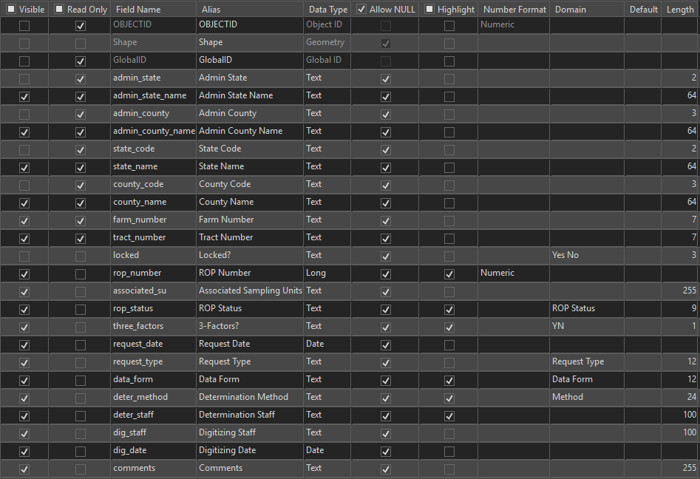

1. *Name*: locked (Required)

*Alias*: Locked

*Data Type*: String/Text

*Length*: 3

*Domain*: Yes-No

*Value Description*: A yes or no indicator intended to control whether the feature can be edited. Placeholder in this version/implementation.

*Default Value*: No

1. *Name*: rop_number (Required)

*Alias*: ROP Number

*Data Type*: Long Integer

*Value Description*: A number assigned by the user to uniquely identify each ROP point. This number does not have to match the Sampling Unit Number

*Default Value*: Null

1. *Name*: associated_su (Required)

*Alias*: Associated Sampling Units

*Data Type*: String/Text

*Length*: 255

*Value Description*: A comma delimited list of sampling unit numbers for associated sampling units that is populated during data validation. It is read from the Sampling Unit Feature Class attribute for Associated ROP. Duplicate entries to the list are reported as errors during validation.

*Default Value*: Calculated by validation.

1. *Name*: rop_status (Required)

*Alias*: ROP Status

*Data Type*: String/Text

*Length*: 9

*Domain*: ROP Status

*Value Description*: Defines whether the ROP is Official or Reference. Only Official ROPs are displayed on the official maps (embed a definition query in the map generation steps).

*Default Value*: Null

1. *Name*: three_factors (Required)

*Alias*: 3-Factors

*Data Type*: String/Text

*Length*: 3

*Domain*: YN

*Value Description*: Y or N. Set to Y or N based on findings while delineating for whether the three factors for wetlands are confirmed.

*Default Value*: Null

1. *Name*: request_date (Required)

*Alias*: Request Date

*Data Type*: Date

*Value Description*: The date of the request that prompted the determination.

*Default Value*: Assigned from required user parameters

1. *Name*: request_type (Required)

*Alias*: Request Type

*Data Type*: String/Text

*Length*: 12

*Value Description*: The type of request that prompted the determination.

*Default Value*: Assigned from required user parameters

1. *Name*: data_form

*Alias*: Data Form

*Data Type*: String/Text

*Length*: 12

*Domain*: Data Form

*Value Description*: Indicates whether a data form/documentation for the ROP was completed.

*Default*: “Undetermined”

1. *Name*: deter_method (Required)

*Alias*: Determination Method

*Data Type*: String/Text

*Length*: 24

*Value Description*: Selected by the user after creating the feature.

*Domain*: Method

*Default*: Null

1. *Name*: deter_staff (Required)

*Alias*: Determination Staff

*Data Type*: String/Text

*Length*: 100

*Value Description*: The name of the person who is doing or did the ROP delineations.

*Default Value*: Current user

1. *Name*: dig_staff (Required)

*Alias*: Digitizing Staff

*Data Type*: String/Text

*Length*: 50

*Value Description*: The name of the person who is digitizing the determination.

*Default Value*: Current user

1. *Name*: dig_date (Required)

*Alias*: Digitizing Date

*Data Type*: Date

*Value Description*: The date of the last edit to the feature.

*Default Value*: Current date or date of last edit/validate

1. *Name*: comments (Optional)

*Alias*: Comments

*Date Type*: String/Text

*Length*: 255

*Value Description*: Used to record any other comments, as needed.

*Default Value*: Null

* + 1. Drainage Lines Feature Class

The Drainage Lines Feature Class is a line feature class that is used to digitized linear features relating to drainage that are relevant to wetland determinations.

* + - 1. Workflow Components and Relationships

The Drainage Lines Feature Class is created in each local project file geodatabase from a template feature class. It contains no records when it is created. Features are created by delineators. This feature class is added to the current project’s map as a layer.

* + - 1. Attributes

The attributes are set by default from the template feature class and are only applied when a delineator selects and draws lines by type and subtype.

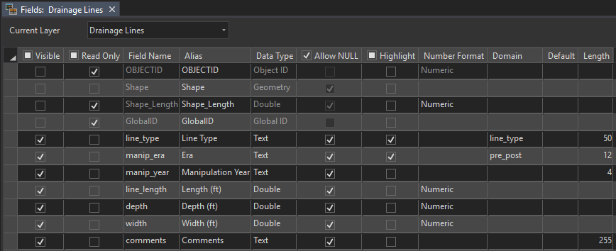

1. *Name*: GlobalID (Required)

*Alias*: GlobalID

*Data Type*: Global ID

*Value Description*: System Generated. Unique ID per feature.

*Default Value*: System generated

1. *Name*: line_type (Required)

*Alias*: Line Type

*Data Type*: String/Text

*Length*: 50

*Domain*: Line Type

*Value Description*: Type of drainage line.

1. *Name*: manip_era (Required)

*Alias*: Era

*Data Type*: String/Text

*Length*: 12

*Domain*: Pre-Post

*Value Description*: Lists whether the drainage line is from before or after 12/23/1985.

*Default Value*: Linked to the feature’s designed symbology.

1. *Name*: manip_year (Optional)

*Alias*: Manipulation Year

*Date Type*: String/Text

*Length*: 4

*Value Description*: Used to enter a specific year, if needed.

*Default Value*: Null

1. *Name*: line_length (Required)

*Alias*: Length (ft)

*Data Type*: Double

*Value Description*: GIS calculated length in feet.

*Attribute Rule*: Calculate upon feature insert or update.

*Default Value*: Calculated by GIS on layer creation/updates.

1. *Name*: depth (Optional)

*Alias*: Depth (ft)

*Data Type*: Double

*Value Description*: User entered depth in feet.

*Default Value*: Null

1. *Name*: width (Optional)

*Alias*: Width (ft)

*Data Type*: Double

*Value Description*: User entered width in feet.

*Default Value*: Null

1. *Name*: comments (Optional)

*Alias*: Comments

*Date Type*: String/Text

*Length*: 255

*Value Description*: Used to record any other comments, as needed.

*Default Value*: Null

* + 1. Potential Jurisdictional Waters Feature Class

The Potential Jurisdictional Waters Feature Class is a point feature class that is used to mark locations that *may* be considered jurisdictional for the Clean Water Act.

* + - 1. Workflow Components and Relationships

The Potential Jurisdictional Waters Feature Class is created in each local project file geodatabase from a template feature class. It contains no records when it is created. Features are created by delineators with a default symbology. This feature class is added to the current project’s map as a layer.

* + - 1. Attributes

There are no attributes for the Potential Jurisdictional Waters Feature Class. The feature class is a simple point feature class with a single symbol.

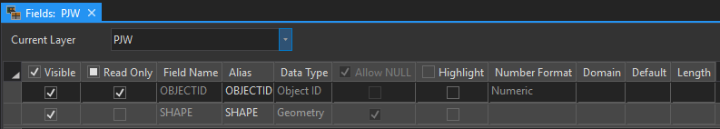

* + 1. Preliminary Technical Determination (PTD) Feature Class

The PTD Feature Class is a polygon feature class that is used to delineate extents for wetland determinations and labels.

* + - 1. Workflow Components and Relationships

The PTD Feature Class is created by clipping the Sampling Units feature class by the determination extent feature class and converting the attributes to appropriate PTD attributes. Additional edits and attribute updates are performed on the PTD Feature Class by delineators. This feature class is added to the current project’s map as a layer.

* + - 1. Attributes

Attributes are inherited from the workflow, system generated, entered by users, or calculated by validation steps. This layer contains its own Global IDs. This layer contains CLU-based attributes and other workflow specific attributes auto-assigned from the Sampling Units Feature Class. The following additional attributes are specific to this layer:

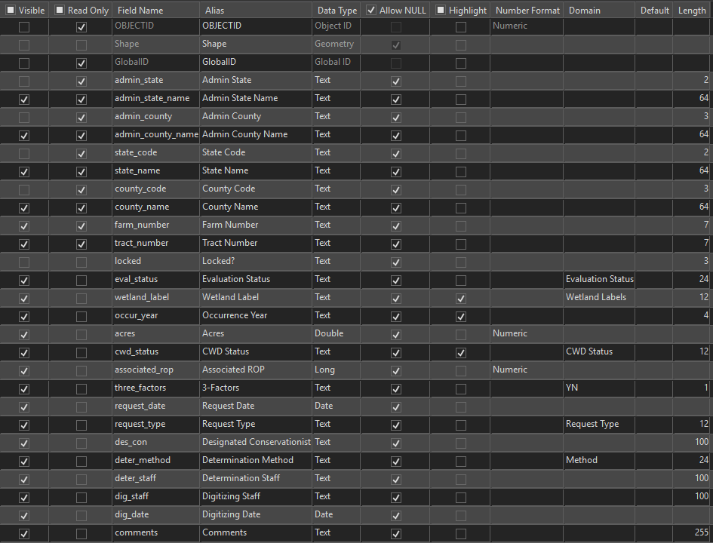

1. *Name*: locked (Required)

*Alias*: Locked

*Data Type*: String/Text

*Length*: 3

*Domain*: Yes-No

*Value Description*: A yes or no indicator intended to control whether the feature can be edited. Placeholder in this version/implementation.

*Default Value*: No

1. *Name*: eval_status

*Alias*: Evaluation Status

*Data Type*: String/Text

*Length*: 24

*Domain*: Evaluation Status

*Value Description*: The workflow type or status of the current polygon feature derived from the determination extent feature class.

*Default Value*: New Request (or others depending on workflow)

1. *Name*: wetland_label (Required)

*Alias*: Wetland Label

*Data Type*: String/Text

*Length*: 12

*Domain*: Wetland Labels

*Value Description*: The official determination’s label for a delineation.

*Default Value*: Null

1. *Name*: occur_year (Optional)

*Alias*: Occurrence Year

*Data Type*: String

*Length*: 4

*Value Description*: The year associated to any wetland label ending in “+”. The date will be constrained to a 4-digit year by validation checks.

*Default Value*: Null

1. *Name*: acres (Required)

*Alias*: Acres

*Data Type*: Double

*Value Description*: Acres calculated by ArcGIS.

*Attribute Rule*: Calculate upon feature insert or update.

*Default Value*: Calculated by GIS on layer creation/updates.

1. *Name*: cwd_status (Required)

*Alias*: CWD Status

*Data Type*: String/Text

*Length*: 12

*Domain*: CWD Status

*Value Description*: Optional attribute that may not be kept up to date after the fact. Status is better tracked through HELC/WC Tracker in Conservation Desktop.

*Default Value*: Preliminary

1. *Name*: associated_rop (Required)

*Alias*: Associated ROP

*Data Type*: Long Integer

*Value Description*: The ROP number of an associated ROP.

*Default Value*: Auto-assigned by validation and processing.

1. *Name*: three_factors (Required)

*Alias*: 3-Factors

*Data Type*: String/Text

*Length*: 3

*Domain*: YN

*Value Description*: Y or N. Set to Y or N based on findings while delineating for whether the three factors for wetlands are confirmed.

*Default Value*: Inherited from the Sampling Unit Feature Class.

1. *Name*: request_date (Required)

*Alias*: Request Date

*Data Type*: Date

*Value Description*: The date of the request that prompted the determination.

*Default Value*: Assigned from required user parameters

1. *Name*: request_type (Required)

*Alias*: Request Type

*Data Type*: String/Text

*Length*: 12

*Value Description*: The type of request that prompted the determination.

*Default Value*: Assigned from required user parameters

1. *Name*: des_con (Optional)

*Alias*: Designated Conservationist

*Data Type*: String/Text

*Length*: 100

*Value Description*: The name of the person who will sign or did sign the 026 form.

*Default Value*: Null

1. *Name*: deter_method (Required)

*Alias*: Determination Method

*Data Type*: String/Text

*Length*: 24

*Value Description*: Selected by the user after creating the feature.

*Domain*: Method

*Default*: Inherited from the Sampling Unit Feature Class.

1. *Name*: deter_staff (Required)

*Alias*: Determination Staff

*Data Type*: String/Text

*Length*: 100

*Value Description*: The name of the person who is doing or did the determination delineations.

*Default Value*: Inherited from the Sampling Unit Feature Class.

1. *Name*: dig_staff (Required)

*Alias*: Digitizing Staff

*Data Type*: String/Text

*Length*: 50

*Value Description*: The name of the person who is digitizing the determination.

*Default Value*: Inherited from the Sampling Unit Feature Class.

1. *Name*: dig_date (Required)

*Alias*: Digitizing Date

*Data Type*: Date

*Value Description*: The date of the last edit to the feature.

*Default Value*: Current date or date of last edit/validate

1. *Name*: comments (Optional)

*Alias*: Comments

*Date Type*: String/Text

*Length*: 255

*Value Description*: Used to record any other comments, as needed.

*Default Value*: Null

* + 1. Certified Wetland Determination (CWD) Feature Class

The CWD Feature Class is a polygon feature class that is used to delineate extents for wetland determinations and labels including FSA CLU field boundaries.

* + - 1. Workflow Components and Relationships

The CWD Feature Class is created by intersecting the PTD feature class with the CLU feature class and automatically updating the attributes to incorporate fields and sub-fields. It is used on the final determination map and transferred to an archive layer when complete that aggregates all work. This feature class is added to the current project’s map as a layer.

* + - 1. Attributes

Most attributes in this feature class are inherited from the PTD Feature Class. CLU Number and CLU Subfield attributes are re-introduced through processing and automatic assignment. Acres are updated according to newly sub-divided delineations. This layer contains its own Global IDs. The following additional attributes are specific to this layer:

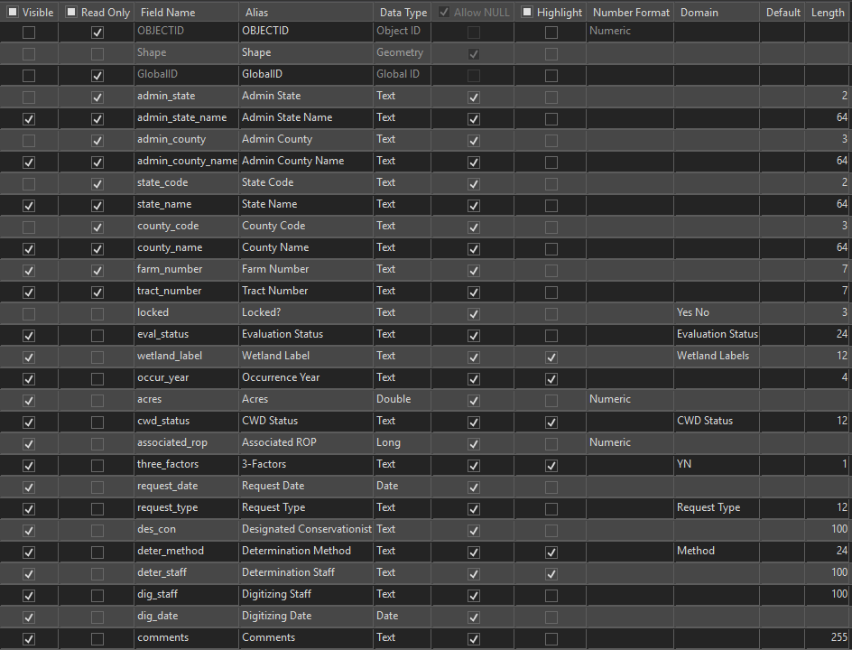

1. *Name*: clu_number (Required)

*Alias*: CLU Number

*Data Type*: String/Text

*Length*: 7

*Value Description*: A 1- to 7-digit field number for each CLU field

*Default Value*: Spatially assigned from the source CLU layer.

1. *Name*: clu_subfield (Optional)

*Alias*: CLU Subfield

*Data Type*: String/Text

*Length*: 7

*Value Description*: Alphabetically assigned lower case letter to distinguish parts of fields split by different wetland delineations.

*Default Value*: Auto-assigned during data creation and validation. If a field has only one delineation, then no subfield is assigned.

1. *Name*: field (Required)  
   *Alias*: Field

*Data Type*: String/Text

*Length*: 14

*Value Description*: Combination of CLU Number and CLU Subfield into a single attribute.

*Default Value*: Auto-assigned during data creation and validation.

1. *Name*: locked (Required)

*Alias*: Locked

*Data Type*: String/Text

*Length*: 3

*Domain*: Yes-No

*Value Description*: A yes or no indicator intended to control whether the feature can be edited. Placeholder in this version/implementation.

*Default Value*: No

1. *Name*: eval_status

*Alias*: Evaluation Status

*Data Type*: String/Text

*Length*: 24

*Domain*: Evaluation Status

*Value Description*: The workflow type or status of the current polygon feature derived from the determination extent feature class.

*Default Value*: New Request (or others depending on workflow)

1. *Name*: wetland_label (Required)

*Alias*: Wetland Label

*Data Type*: String/Text

*Length*: 12

*Domain*: Wetland Labels

*Value Description*: The official determination’s label for a delineation.

*Default Value*: Null

1. *Name*: occur_year (Optional)

*Alias*: Occurrence Year

*Data Type*: String

*Length*: 4

*Value Description*: The year associated to any wetland label ending in “+”. The date will be constrained to a 4-digit year by validation checks.

*Default Value*: Null

1. *Name*: acres (Required)

*Alias*: Acres

*Data Type*: Double

*Value Description*: Acres calculated by ArcGIS.

*Attribute Rule*: Calculate upon feature insert or update.

*Default Value*: Calculated by GIS on layer creation/updates.

1. *Name*: cwd_status (Required)

*Alias*: CWD Status

*Data Type*: String/Text

*Length*: 12

*Domain*: CWD Status

*Value Description*: Optional attribute that may not be kept up to date after the fact. Status is better tracked through HELC/WC Tracker in Conservation Desktop.

*Default Value*: Preliminary

1. *Name*: associated_rop (Required)

*Alias*: Associated ROP

*Data Type*: Long Integer

*Value Description*: The ROP number of an associated ROP.

*Default Value*: Auto-assigned by validation and processing.

1. *Name*: three_factors (Required)

*Alias*: 3-Factors

*Data Type*: String/Text

*Length*: 3

*Domain*: YN

*Value Description*: Y or N. Set to Y or N based on findings while delineating for whether the three factors for wetlands are confirmed.

*Default Value*: Inherited from the Sampling Unit Feature Class

1. *Name*: request_date (Required)

*Alias*: Request Date

*Data Type*: Date

*Value Description*: The date of the request that prompted the determination.

*Default Value*: Assigned from required user parameters

1. *Name*: request_type (Required)

*Alias*: Request Type

*Data Type*: String/Text

*Length*: 12

*Value Description*: The type of request that prompted the determination.

*Default Value*: Assigned from required user parameters

1. *Name*: des_con (Optional)

*Alias*: Designated Conservationist

*Data Type*: String/Text

*Length*: 100

*Value Description*: The name of the person who will sign or did sign the 026 form.

*Default Value*: Null

1. *Name*: deter_method (Required)

*Alias*: Determination Method

*Data Type*: String/Text

*Length*: 24

*Value Description*: Selected by the user after creating the feature.

*Domain*: Method

*Default*: Inherited from the Sampling Unit Feature Class.

1. *Name*: deter_staff (Required)

*Alias*: Determination Staff

*Data Type*: String/Text

*Length*: 100

*Value Description*: The name of the person who is doing or did the determination delineations.

*Default Value*: Inherited from the Sampling Unit Feature Class.

1. *Name*: dig_staff (Required)

*Alias*: Digitizing Staff

*Data Type*: String/Text

*Length*: 50

*Value Description*: The name of the person who is digitizing the determination.

*Default Value*: Inherited from the Sampling Unit Feature Class.

1. *Name*: dig_date (Required)

*Alias*: Digitizing Date

*Data Type*: Date

*Value Description*: The date of the last edit to the feature.

*Default Value*: Current date or date of last edit/validate

1. *Name*: comments (Optional)

*Alias*: Comments

*Date Type*: String/Text

*Length*: 255

*Value Description*: Used to record any other comments, as needed.

*Default Value*: Null

* + 1. Compliance Records Tract Index Feature Class

This is a tract-based index with hyperlinks to an ongoing PDF archive of compliance determination records for the tract, modeled after the layer and files produced for this purpose by NRCS Iowa.

* + - 1. Workflow Components and Relationships (Pending)
      2. Attributes (Pending)
    1. State Administrative Feature Class

This is a statewide feature class that must be created and maintained by each state consisting of county boundaries and each county is assigned attributes for its service center, team, area, and state.

* + - 1. Workflow Components and Relationships

This layer is used to support operations dashboards relating to the wetlands data. It’s used to tag attributes to other feature classes that are uploaded to maintain current data on the dashboards.

* + - 1. Attributes (Pending)
  1. GeoPortal Data Model

This portion of the data model is for layers to be stored on GeoPortal, state by state, which serve as data repositories for completed determination extents and labels. The layers interact with the wetland determination workflow by receiving uploaded data for newly completed determinations and by providing downloaded data to integrate into new projects. The layers also provide the capability to be used in operations dashboards.

* + 1. Current Sampling Units

This is a hosted feature layer on GeoPortal, one per state, that stores the currently completed sampling unit polygons physically located within that state.

* + - 1. Workflow Components and Relationships

This layer is created by uploading and overwriting sampling units for completed determinations in a project’s active determination extent. It is also used to import existing sampling units into new projects.

* + - 1. Attributes

Same as the Sampling Units Feature Class.

* + 1. All Sampling Units (Pending)

Intended to store all sampling units, allowing overlap.

* + - 1. Workflow Components and Relationships (Pending)
      2. Attributes

Same as the Sampling Units Feature Class.

* + 1. Current Wetland Determinations

This is a hosted feature layer on GeoPortal, one per state, that stores the currently completed wetland determination polygons physically located within that state.

* + - 1. Workflow Components and Relationships

This layer is created by uploading and overwriting completed determinations in a project’s active determination extent. It is also used to import previous determinations into new projects. Lastly, it is used to generate data in the Determination Job Extents and Determination Job Point layers for use in Operations Dashboards.

* + - 1. Attributes

Same as the Wetland Determinations Feature Class.

* + 1. All Wetland Determinations

Intended to store all determination polygons, allowing overlap.

* + - 1. Workflow Components and Relationships (Pending)

2.2.4.2 Attributes

Same as the Wetland Determinations Feature Class.

* + 1. Current Certified Wetland Determinations

This is a hosted feature layer on GeoPortal, one per state, that stores the currently completed certified wetland determination polygons physically located within the state.

* + - 1. Workflow Components and Relationships

This layer is created by uploading and overwriting completed certified determinations in a project’s active determination extent.

* + - 1. Attributes

Same as the Certified Wetland Determinations Feature Class.

* + 1. All Certified Wetland Determinations (Pending)

Intended to store all certified wetland determinations, allowing overlap – i.e. all original determinations are stored regardless of any revisions or recisions.

* + - 1. Workflow Components and Relationships (Pending)
      2. Attributes

Same as the Certified Wetland Determinations Feature Class.

* + 1. Determination Job Extents

This layer consists of determination extents, stored state by state on GeoPortal. It is also contains county, team, and area designation attributes.

* + - 1. Workflow Components and Relationships

Created by intersecting the determination the State Administrative Feature Class. Then the extent gets dissolved again, using CWD Status, geographic county FIPS, geographic county FIPS name, team name, area name, tract number, method, digitizing staff, digitizing date with the “FIRST” option for any attributes of County, Team, and Area to return to a single extent (in case of encountering any county boundaries). The extent is then uploaded to the GeoPortal Hosted Feature Service which is used by an Operations Dashboard.

* + - 1. Attributes

A combination of the Determination Extent Feature Class and the State Administrative Feature Class attribute schema.

* + 1. Determination Job Points

A point version of the Determination Job Extents layer for use in Operations Dashboards.

* + - 1. Workflow Components and Relationships

Created by converting the Determination Job Extent to a point, joining it to and appending it to a GeoPortal Hosted Feature Service which is used by an Operations Dashboard.

* + - 1. Attributes

Same as the Determination Job Extents Hosted Feature Service.

* + 1. Determination Points

This layer consists a point representation of the Determinations Feature Class with information added for counties, teams, and areas stored as a hosted feature service on GeoPortal, state by state, and used by Operations Dashboards.

* + - 1. Workflow Components and Relationships

This layer is created by converting the Determinations Feature Class from polygon to point geometry and intersecting the points with the State Administrative Feature Class.

* + - 1. Attributes

Same as a combination of the Determinations Feature Class with the State Administrative Feature Class.

* 1. Data Model Domains

This section describes the attribute choice lists that will be configured for each feature class. Feature class descriptions might include one or more of the following domains.

* + 1. YN Domain

Y

N

* + 1. Yes-No Domain

Yes

No

* + 1. ROP Status Domain

Official

Reference

* + 1. Data Form Domain

Yes

No

Undetermined

* + 1. Line Type Domain

Drainage Ditch

Underground Tile

Manipulated Natural Water Course

Other

* + 1. Pre-Post Domain

Pre-1985

Post-1985

* + 1. Method Domain

Level 1 – Offsite

Level 2 – Onsite

Level 3 – Combination

Level 1 – SOSM

Level 3 – SOSM

* + 1. CWD Status Domain

Preliminary

Appealed

Final

* + 1. Request Type Domain

AD-1026  
FSA-569  
NRCS-CPA-38

* + 1. Evaluation Status Domain

New Request

Revision  
Certified-Digital  
Certified-Paper

* + 1. Wetland Labels Domain

The content and order of the following list has been specified by agency leadership in charge of wetland conservation compliance as of 8/31/2020.

NW Non-Wetland

PC Prior-Converted Cropland

W Wetland

FW Farmed Wetland

FWP Farmed Wetland Pasture or Hayland

AW Artificial Wetland

WX Manipulated Wetland

MIW Mitigation Exemption

MW Minimal Effect Exemption

MWM Mitigation Site

TP Third Party Exemption

CW+ Converted Wetland plus year

CW Converted Wetland

CWIL Converted Wetland In-Lieu Fee

CWTA Converted Wetland Timely Assistance

CWTE Converted Wetland Technical Error

CPD Corps Permit Decision

PC/NW Prior-Converted Cropland/Non-Wetland

AW/FW Artificial Wetland/Farmed Wetland

AW/W Artificial Wetland/Wetland

NW/NAD Non-Wetland per National Appeals Division decision

CC Commenced Conversion

CWNA Converted Wetland for Non-Agricultural Purposes

NI Not Inventoried

* 1. Source Datasets

This is a list of data sources that may be consumed by the wetland determination tool.

* + 1. FSA CLU (from FSA Web Service)

https://gis.sc.egov.usda.gov/appserver/rest/services/common_land_units/common_land_units/FeatureServer/0

* + 1. NRCS Soil Survey (Soil Data Access)

https://SDMDataAccess.sc.egov.usda.gov/Spatial/SDMWGS84Geographic.wfs

* + 1. USGS NHD

https://gis.sc.egov.usda.gov/data/rest/services/hydrography/nhd/FeatureServer

* + 1. US FWS National Wetland Inventory (NWI)

https://gis.sc.egov.usda.gov/data/rest/services/wetlands/national_wetland_inventory/MapServer

* + 1. USGS Topographic Quadrangle Maps

https://gis.sc.egov.usda.gov/data/rest/services/topographic_images/usa_topo_maps/MapServer

* + 1. Best Available NAIP

https://gis.sc.egov.usda.gov/data/rest/services/ortho_imagery/naip/MapServer

* + 1. NRCS Elevation Services

1m Service:

https://gis.sc.egov.usda.gov/image/services/elevation/bare_earth_1m/ImageServer

2m Service: https://gis.sc.egov.usda.gov/image/services/elevation/bare_earth_2m/ImageServer

3m Service:

https://gis.sc.egov.usda.gov/image/services/elevation/bare_earth_3m/ImageServer

5m Service:

https://gis.sc.egov.usda.gov/image/services/elevation/bare_earth_5m/ImageServer

* + 1. NRCS Wetland Determination Climate Data (WETS)
    2. Local Digital Datasets

Various. Managed by state coordinators.

Examples: Ecosites, vegetation, High Resolution Digital Elevation Data and Derivatives, Government Land Office Maps, Historical Ortho Rectified Aerial Photography, FSA Crop Compliance Aerial Photos

* 1. Coordinate Systems
     1. GeoPortal Layers

*WGS84 Geographic* or *WGS84 WMAS*

* + 1. State/Local APRX Template Maps

State Coordinators/Administrators set a Coordinate System. They also set a Transformation from their selected coordinate system to WGS84.

Recommendations -   
Projected Coordinate System: *NAD 1983 UTM* (zone applicable to region/zone)

Transformation (if using NAD 1983 UTM): *WGS 1984 (ITRF00) to NAD 1983*

* + 1. Determination Tool Project Datasets

Read and adopt the Coordinate System from the State/Local APRX Template map frame.

* + 1. Local Reference Datasets

Varies. Provided by states.

* 1. Accuracy

The map products from this data model and the related wetland determination tool are representations, as is the case with all maps. All efforts are made to make maps as accurate as possible for the purposes of sharing information and communicating determination results. It should be noted that certified map delineations representing areas with assigned labels by this process are often not the official boundaries of an ineligible area. In many cases, the specific area of ineligibility will be determined by on site observation and delineation on the ground.

* + 1. Horizontal Accuracy

Horizontal accuracy for this standard is recommended to be similar to the NRCS conservation planning and the FSA CLU datasets as described in the 8-CM (Revision 1) Amendment 4 (USDA Farm Services Agency, 2012).

When the determination delineation source is hand drawn, on-screen (offsite) digitizing, the digitizing scale is recommended to be 1:4,800 or larger. Larger scales can be used where high-resolution aerial imagery is available.

When the determination delineation source is GPS, the maximum expected horizontal accuracy should not exceed 6.1 meters (20 feet). The actual expected horizontal accuracy, if the standard is adhered to, will be less than 3 meters under optimum conditions (USDA-NRCS, 2010).

* + 1. Accuracy Assessment

Accuracy assessment is a quantitative assessment (comparison of determinations conducted with methods and equipment capable of providing a higher level of accuracy) of boundary line positions and labeling, indicating the percentage of features that are in agreement.

**By National Policy, no specification for Accuracy Assessment is required in this standard.**

* 1. Topology Rules and Logical Consistency (Pending)
  2. Metadata (Pending)

1. References

NRCS FSA, 2006:

*Final Report to Address Interagnecy Handling of Wetlands Conservation Compliance Documents Relating to the Use of ‘Blue Dots’*

USDA Farm Services Agency, 2012:

*Common Land Unit 8-CM (Rev. 1) Amend. 4. S.1*

USDA-NRCS, 2010:

*GPS Data Collection Standards for Conservation Planning, Technical, and Financial Assistance, s.1*

1. Participants

Denise Coleman

Dwain Daniels

Adolfo Diaz

Kevin Godsey

Paige Guetter

Gregg Hadish

Melissa Hanner

Jennifer Heglund

Kathy Irving

Joan Kinley-Howard

Darren Manthei

David Manthei

Chris Morse

Edwin Muniz

Jason Outlaw

Dee Pederson

Yuri Plowden

Ryan Ransom

Brent Stinson

Jeffrey Zimprich